**Hotel management system**

**Minor project report**

Submitted in partial fulfilment of the requirements for the award of the degree of

BACHELOR OF ENGINEERING

IN

MECHANICAL ENGINEERING

TECH BOYS( OPERATION BLACK)

BY

GOUTHAM BASKER LALITH ADITHYAA.S

ROLL NO: 111722106007 ROLL NO: 111722106012

AKASH AJAY NAIR

ROLL NO: 111722106002

GUIDED BY

DR. SATHIAMOORTHY.J

ASSOCIATE PROFESSOR

Table of content

1. introduction
   1. purpose
   2. scope of the project
   3. overview
   4. product perspective

2.0 product perspective

2.1 Functional requirements

2.2 Non-functional requirements

2.3 Performance requirements

2.4 Security requirements

2.5 Specific requirements

2.6 Software Interface

2.7 Hardware Interface

2.8 Assumption and Dependencies

CANDIDATES’ DECLARATION

It is hereby certified that the work which is being presented in the B. Tech Minor Project Report entitled “TECH BOYS (OPRATIONAL BLACK)” in partial fulfilment of the requirements for the award of the degree of Bachelor of Enginneering and submitted in the Department of Mechanical engineering of R.M.K Engineering college (An Autonomous Institution ) Approved by AICTE , New Delhi & Affiliated to Anna University , Chennai is an authentic record of our own work carried out in month December 2022 under the guidance of DR. SATHIAMOORTHY.J, Associate Professor .

GOUTHAM BASKER LALITH ADITHYAA.S

ROLL NO: 111722106007 ROLL NO: 111722106012

AKASH AJAY NAIR

ROLL NO: 111722106002

This is to certify that the above statement made by the candidate is correct to the best of my knowledge. They are permitted to appear in the External Major Project Examination.

ACKNOWLEGEMENT

We express our deep gratitude to. DR.SATHIAMOORTHY.J, Assistant Professor, Department of Electronics & communication engineering for her valuable guidance and suggestion throughout my project work.

We would like to extend our sincere thanks to Prof. DR. Senthil Kumar, Head of Department, for his time-to-time suggestions to complete our project work. We are also thankful We would also like to thank our families and friends, who helped us in every possible way.

**INTRODUCTION**

1. **Introduction**

Today Developers around the world are making efforts to enhance user experience of using application as well as to enhance the developer’s work flow of designing applications to deliver project’s and rollout change requests and strict timeline. Stacks can be used to build web applications in the shortest span of time. The stacks used in the web development are basically the response of software engineers to current demands. They have essentially adopted pre-existing frameworks to make their lives easier.

* 1. **PURPOSE**

This Hotel Management System Software Requirement Specification (SRS) main objective is to provide a base for the foundation of the project. It gives a comprehensive view of how the system is supposed to work and what is to be expected by the end users. Client’s expectation and requirements are analysed to produce specific unambiguous functional and non-functional requirements, so they can be used by development team with clear understanding to build a system

as per end user needs. This SRS for HMS can also be used for future as basis for detailed understanding on how project

was started. It provides a blueprint to upcoming new developers and maintenance teams to assist

in maintaining and modifying this project as per required changeability

1. In this world of growing technologies everything has been computerized. With large number of
2. work opportunities the Human workforce has increased. Thus there is a need of a system which
3. can handle the data of such a large number of Employees in an organization. This project
4. simplifies the task of maintain records because of its user friendly

1.2 Scope of the Project

The HMS project is intended for the reservations for room that can be made through online. It will be able to automate the various operations of the Hotel. Our Hotel Management System will have three end users: Customer, Receptionist, and Hotel Manager. Hotel Management System will consist of Booking Management System, DBMS Server, and Report Generator. Customers will be able to check for room’s availability, select the rooms, and pay for the room. Receptionist will have access to update or modify booking details. Manager will able to view the financial report and able to update room information such as cost and category. The main goal of this introduced automated HMS software is to simplify every day process of hotel. Day to day Hotels are increasing and they need to automate to provide customer ease of access. It will be able to take care of services to customer in a quick manner. This automation will be able to replace the drawbacks of large customer information physical files which were difficult to handle. Secure Transaction, quick retrieval of information, ease of use, quick recovery of errors, fault tolerance are some of the benefits that development team will be working on to achieve end user satisfaction.

1.3 Overview

The remaining sections of this documentations describes the overall descriptions which includes product perspective and functions, characteristics of users. It also consists of Assumptions, and Constraints. Overall description is listed in section 2. Section 3 includes Specific Requirements which consists of Functional and Non-functional requirements, External Interface Requirements, Software System Attributes, Performance Requirements, Capacity Requirements, Availability Requirements, Safety Requirements and Requirement Traceability Matrix.

2.0 Product perspective

This system here is developed to book room by customers and sending information of customers to recipients and checking the availability of rooms. the customer can see the vacant room information and the cost of booking the room. Manager can view any report such as financial report, customer information, booking information, and room information, analyse them and take the decision accordingly.

2.1 functional requirements

* Keep track of reservations.
* Keep track of the customer's first name.
* Keep track of the customer's last name.
* Keep track of the number of occupants.
* Keep track of the room number.
* Show the default room rate
* Make a note of the customer's phone number.
* Indicate whether the room is assured.
* Create a unique confirmation number for each transaction.
* Make a note of the anticipated check-in date and time.
* The system must keep track of the anticipated checkout date and time.
* Customers will be checked in by the system.
* The system must allow reservations to be changed without requiring the customer to resubmit all their information.
* Customers will be checked out by the system.
* If the customer checks out after 11:00 a.m., the system will charge them for an extra night. After 6:00 p.m. on the check-in date, the system will mark assured rooms as "Must pay."
* The system will keep track of consumer feedback.

2.2 non functional requirements

In addition to the core behavioral processes outlined in the system features section, the Hotel Management System (HMS) is expected to have a number of other attributes. After discussing what is expected of the HMS, it is determined that the functional needs included in the report's system features section are critical to the system's functionality, and hence must be implemented. However, because only a few of the non-functional needs listed in this section are critical to the system's functionality, their realization may be termed inessential. Because these needs are minor aspects of how the system is supposed to operate, the system can run as intended without them.

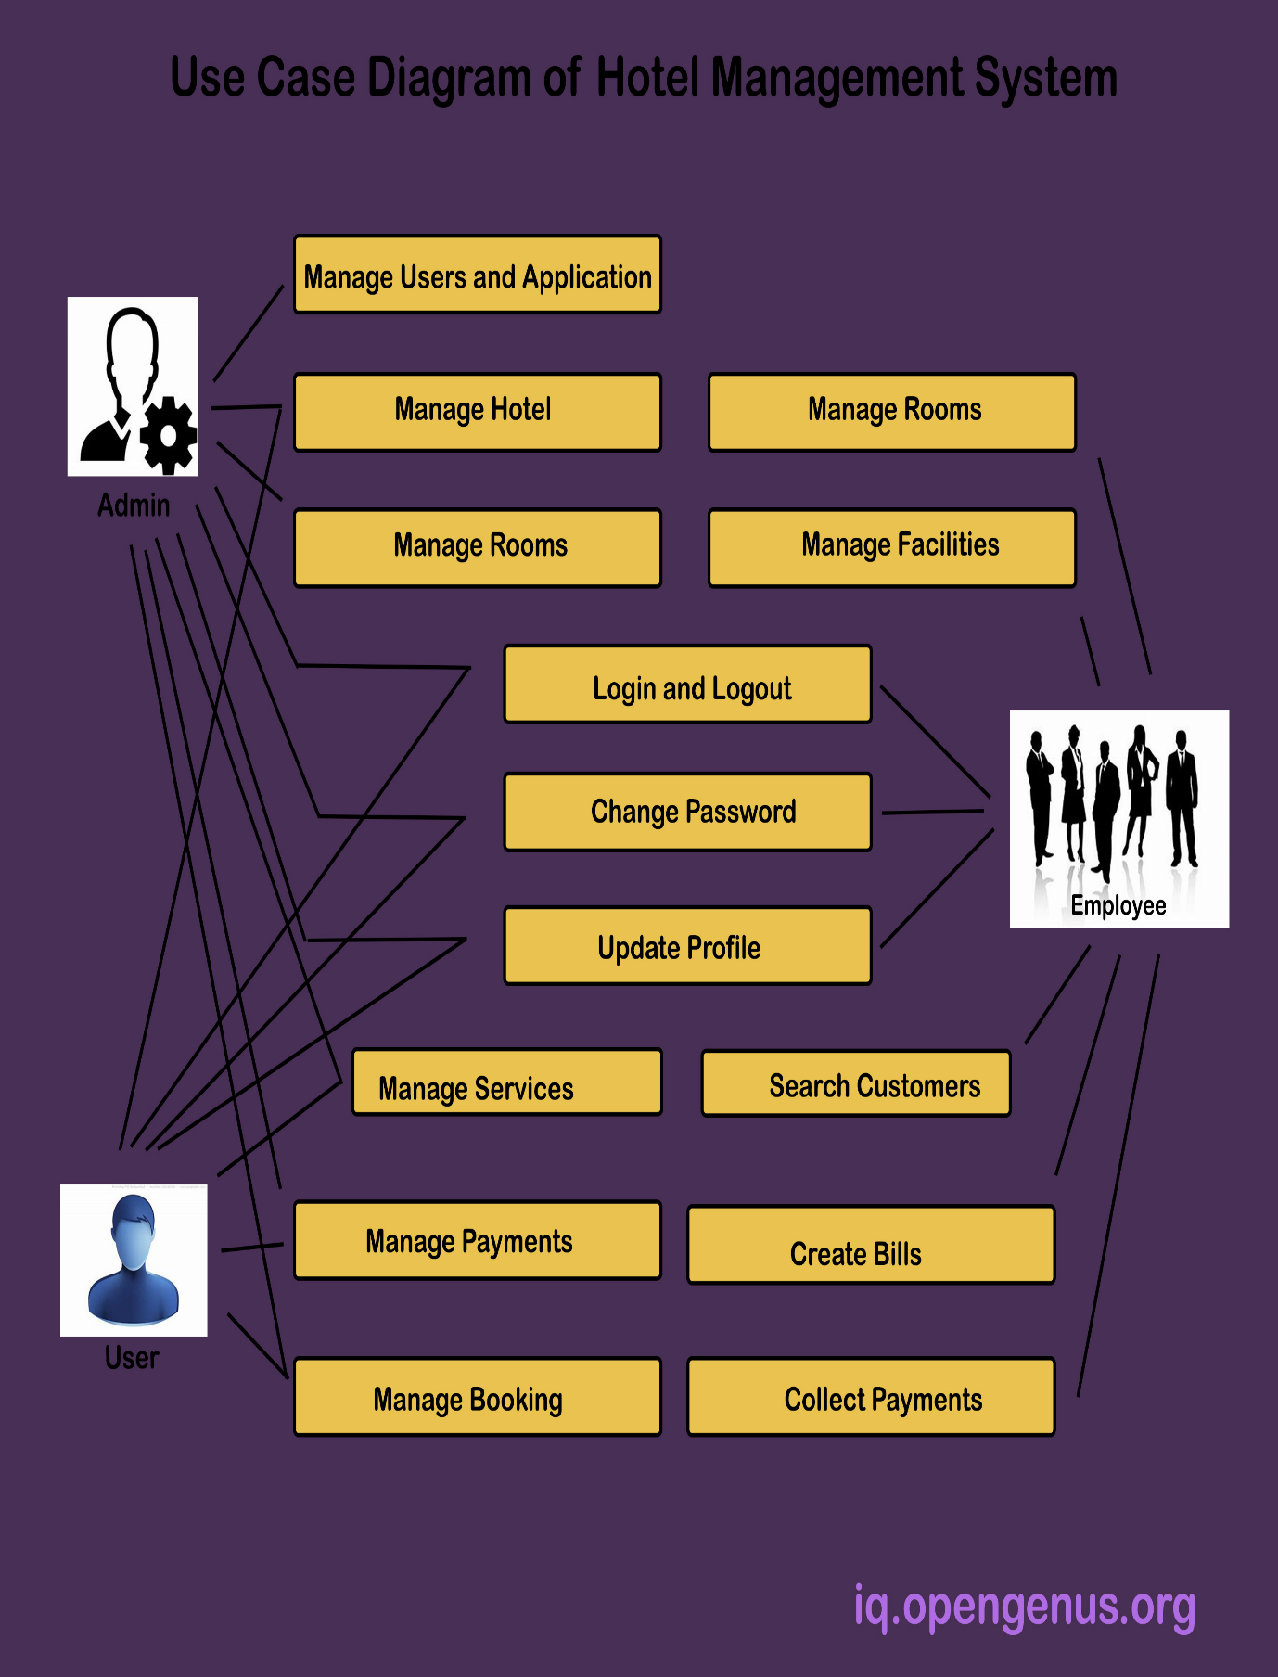

.

2.3 Performance Requirements

Time it takes for the system to respond

Response time is one of the most important performance requirements to consider when creating the Hotel Booking System. The system must be able to respond promptly to the user's inputs and requests; any delays between the user's inputs and the system's response (if necessary) should be kept to a minimal, for example, while retrieving customer information for a booking.

Efficiency of the System

For a system like this, efficiency is critical; during peak demand periods, the system should be able to always perform at its highest level. Efficiency, in this context, refers to how the system leverages the inputs from the users to generate the output. In some ways, even though a system produces an output, it can still be considered inefficient if the input to output ratio is negative.

Fast Loading

Along with reaction times, the system's loading speeds must be quick. Users should not have to wait significant amounts of time to have access to information within the system.

2.4 Security Requirement

User Login

To prevent unauthorized personnel from accessing the system, some type of user login method will be implemented. Any member with system access will be asked to have a username and password that allows them to access the system's features.

Levels of Access

The system is expected to have several access levels depending on which staff member is accessing the system, such as hotel personnel or management, to assist prevent unauthorized parties from accessing, viewing, or changing parts and information within the system. This means that certain features of the system will be restricted to select individuals based on their level of power inside the firm.

Protection of Personal Information

It is critical for the company to maintain the privacy of customer information; this requirement is in line with the regulations of the Data Protection Act 1998, and thus it is critical for the system to be implemented with the goal of maintaining the data confidentiality of the customers on whom they hold information. The system is intended to be able to securely store data and retrieve it when needed.

Considering the security standards, certain information within the system may need to be restricted to select members of the company's workforce. At the highest access level, for example, information will only be accessible to authorized personnel such as hotel managers and/or supervisors; if enabled, a password may be required to access such a level.

Verification (fingerprints, ID cards)

System authentication is by far one of the most important forms of security that should be integrated into this system, on top of all the other security measures stated above. Returning to the access levels, an authentication mechanism such as ID scanning might be used at various access levels to validate certain staff members and grant them access to specified system elements.

2.5 Specific Requirements

* External Interface Requirements
* User Interfaces
* The system's user interface must work with any web browser, including Mozilla Firefox, Google Chrome, and Internet Explorer.

2.6 Software Interfaces

* Web Server

Apache Server, OS (Windows)

* Language

Java/ C++/ Python/ any multithreading capable OOP based language

* Database Server

MySql, OS (Windows)

2.7 Hardware Interfaces

Server Side

Monitor Resolution: 1024 x 768

Processor: Intel or AMD 2GHZ

RAM: 4GB

Disk Space: 10GB

Client Side

Monitor Resolution: 1024x768

Processor: Intel or AMD 1GHZ

RAM: 512MB

Disk Space: 2GB

2.8 Assumption and Dependencies

It is assumed that system developed will work perfectly that’s going to be developed under the Windows OS, and Apache Server with Mongo DB database. If incase of any difficulties, SRS should be flexible enough to change accordingly.